How to Type Daily Lesson Plans in Forethought

- In My Planner, click in the grey box of the course for which you are planning. The scope and sequence will appear on the right side of the screen.

- To add a student expectation from the scope and sequence tree, double click the standard and it will be added to the grey standards box.
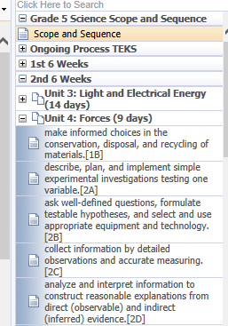
- The default template for lesson plans is automatically displayed in the white planning space. You will type your daily lesson in this space. (you will see a few word processing features at the top of the screen that will allow you to change the font size, color, etc.)

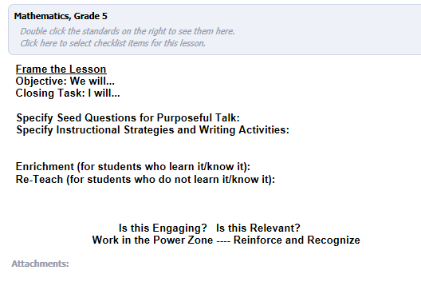

- Click the paper clip icon in the bottom right of the planning area to attach documents to your lesson plans. The paper clip will only be active if you are actively working in that planning space.

- Click the calendar icon to see options for viewing your planner in different ways. You may want to view the entire week or you may want to plan by course, which allows you to see just one course for the entire week in your planner.
