Excel Basics

- Open Microsoft Excel

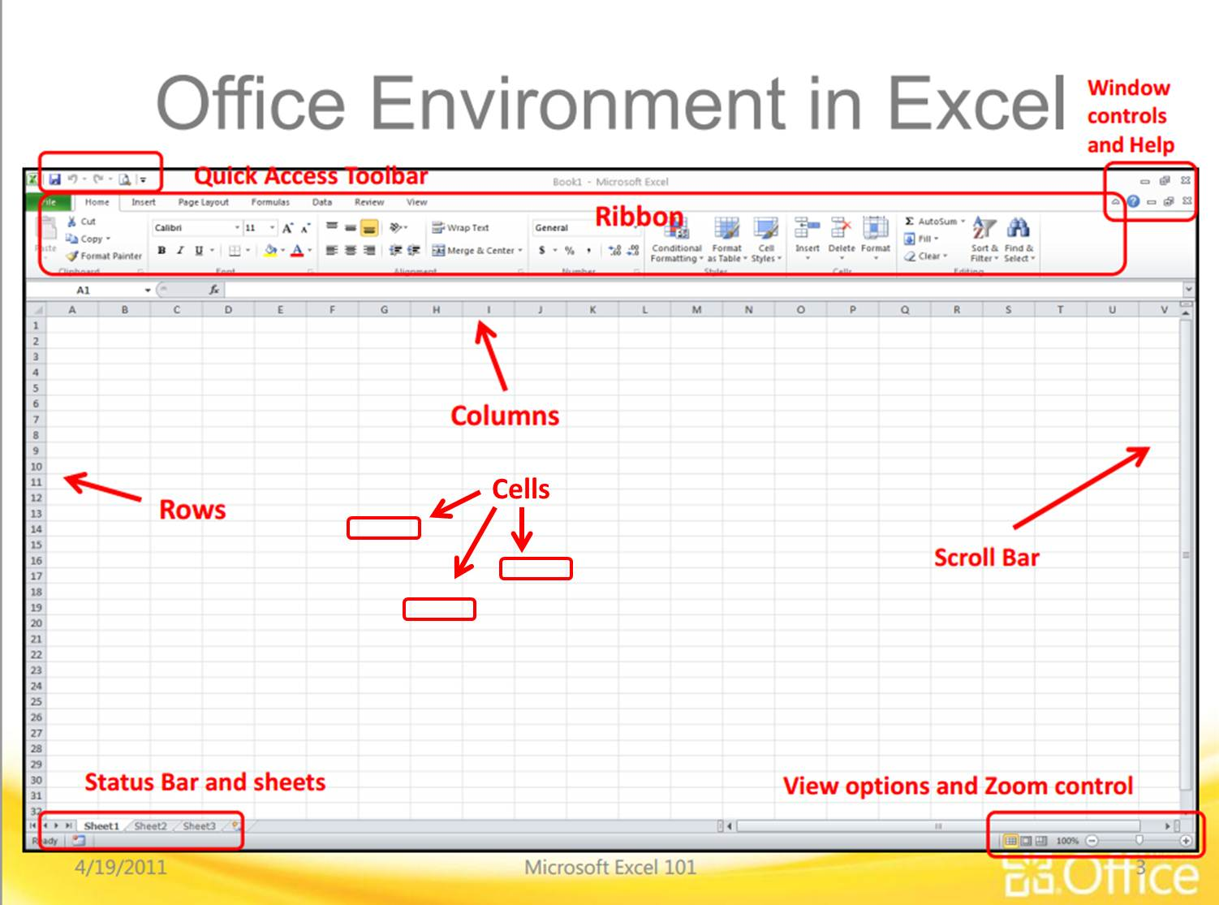
- Take a look at this picture to start learning the names of things in Excel:

Excel is used for making spreadsheets. A spreadsheet is used to organize information and numbers. You can make graphs and charts in excel. You can sort information. You can do math (even complicated math). You can make tables. You can do many things, but these are the basics that we will cover.

